|  |  |
| --- | --- |
|  | **2019** |
|  | University of North Texas  CSCE Software Engineering Deliverable 1 |

|  |
| --- |
| **Bon VIVEUR** |
| **Group Number 4**  Anurdha Vishwapriya Niradi  Sravya Bussoli  Sravya Garlapati  Harshitha Mandru |

**Project description**

Bon Viveur is a French word which means a person who loves food and this project is a website development for such people who miss their home food far away from home. The website will have 6 regions (as of now)-Dallas, Fort Worth, Arlington, Plano, Frisco and Irving, which will have actual families as vendors who will cook their special food and take orders from their menu provided on the website while the customer can order his choice depending upon his region and pick up the food.

Preparation time will be specified in the menu for each dish. We can use a third party to deliver the food which is future scope of the project. We are planning to narrow the food cuisine to India and regions in Texas since we are in Texas and starting up. The languages that we will be using are PHP 7, HTML5, MySQL, CSS since these are used in Front-end development projects.

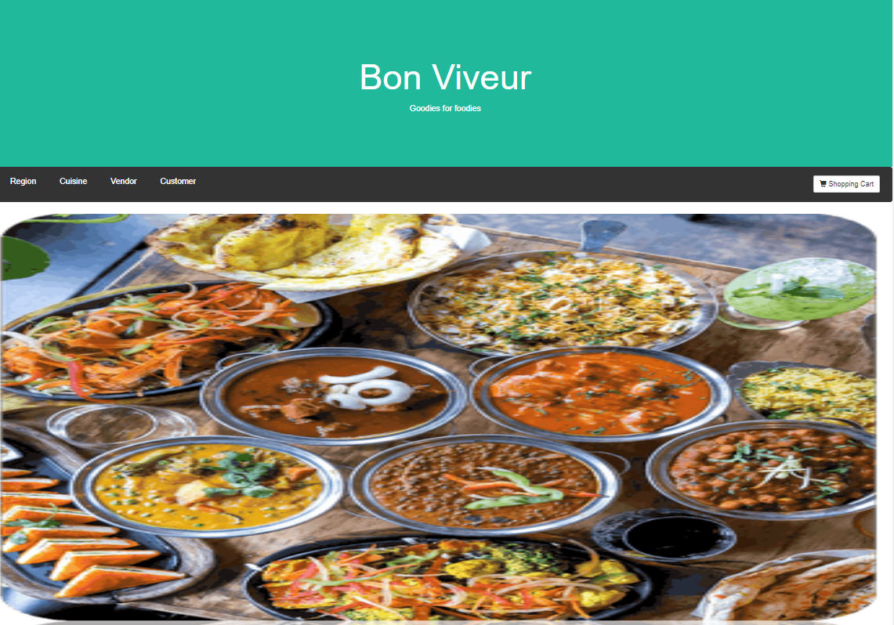

**Initial Plan**

The initial plan of the project is shown below with the necessary components. We can add more features depending upon the requirements.

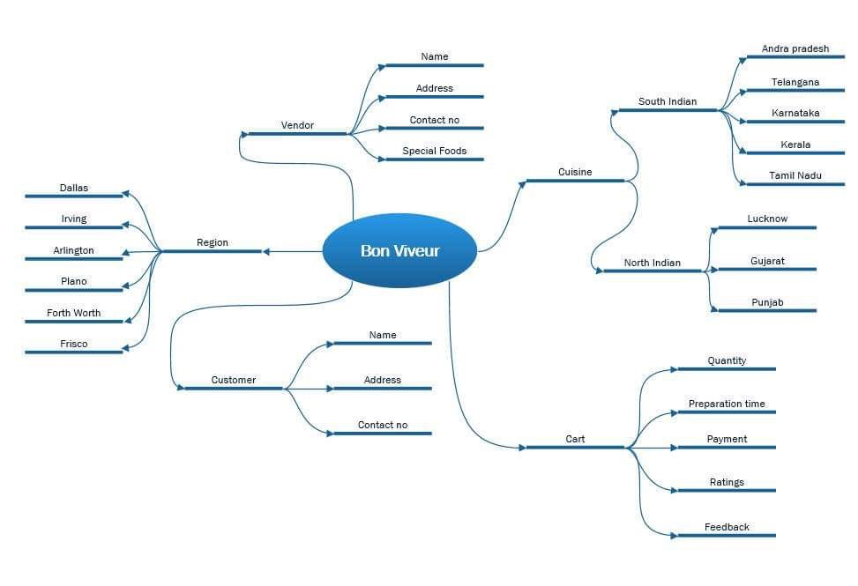

Figure : Overall initial project plan

**Gantt Chart**

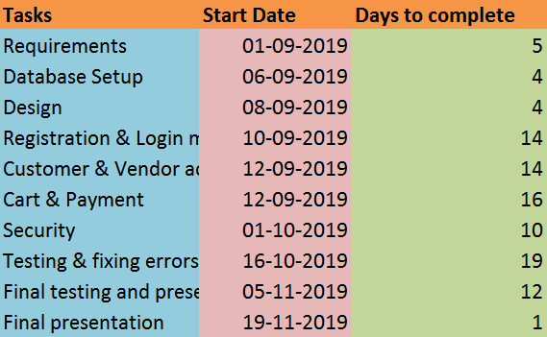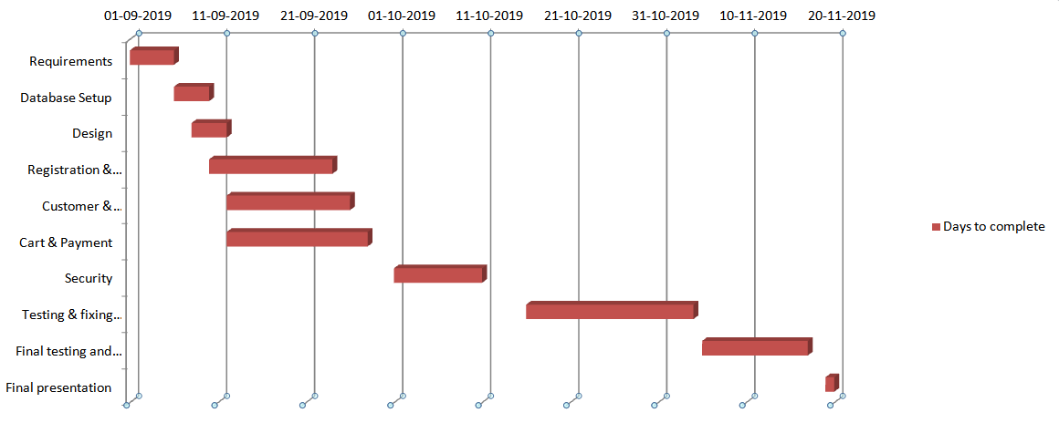

Figure : Gantt chart

The project will flow as follows.

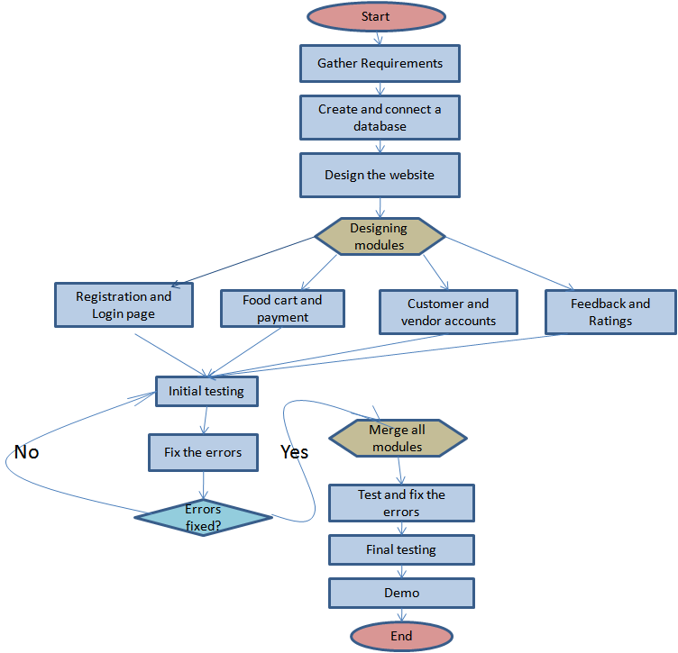

Figure : Flow chart of project plan

**Risk management**

|  |  |  |
| --- | --- | --- |
| **Risk** | **Monitor** | **Evaluation &**  **Contingency Plan** |
| Exceeding timeframe | Checking if everyone is completing tasks on time | Staying ahead of time with proper plan and testing often to avoid delay in last minute |
| Scaling | Checking if any addition of features take more time and result in complex system | In case of addition of features, check for need and how much it affects the whole system |
| Change of requirements | Check if the features have extra requirements periodically | Evaluate the requirements and finding out if they are really necessary before adding so that it doesn't end up with too many by the end of the project |

**Team member and their roles**

1. **Anuradha Vishwapriya Niradi** will be responsible for repository creation, documentation, presentations, database setup, customer and vendor account module code, cart and payment module code, initial testing, fixing errors in the respective module codes and final testing.
2. **Harshitha Mandru** will be responsible for gathering requirements, presentations, database setup, customer and vendor account module code, cart and payment module code, initial testing, fixing errors in the respective module codes and final testing.
3. **Sravya Garlapati** will be responsible for gathering requirements, registration and login module code, security features for the website, initial testing, fixing errors in the respective module codes and final testing.
4. **Sravya Bussoli** will be responsible for registration and login module code, security features for the website, initial testing, fixing errors in the respective module codes and final testing.